TWO-WAY BETWEEN-SUBJECTS ANOVA
Effects of Movie Volume and Popcorn Type on Popcorn Consumption
[NAME]
[DEPARTMET, UNIVERSITY]
[COURSE CODE: COURSE NAME]
[PROFESSOR NAME]
[ASSIGNMENT DUE DATE]

Effects of Movie Volume and Popcorn Type on Popcorn Consumption

Results
A 2 × 2 between-subjects analysis of variance (ANOVA) was conducted to examine the effects of type of popcorn (plain vs. buttered) and movie volume (soft vs. loud) on the amount of popcorn consumed (in grams).

Assumption Testing
The assumption of homogeneity of variances was assessed using Levene’s test. Levene’s test was not statistically significant, F(3, 36) = 0.16, p = .921, indicating that the assumption of equal variances across groups was met.

Main Effect of Popcorn Type
The main effect of popcorn type was not statistically significant, F(1, 36) = 0.24, p = .628, Partial Eta Squared = .007. This result indicates that overall popcorn consumption did not significantly differ between participants who consumed plain popcorn (M = 23.05) and those who consumed buttered popcorn (M = 23.55).

Main Effect of Movie Volume
The main effect of movie volume was statistically significant, F(1, 36) = 4.22, p = .047, Partial Eta Squared = .105. Participants consumed significantly more popcorn when the movie was played at a loud volume (M = 24.35) than when it was played at a soft volume (M = 22.25).

Interaction Between Popcorn Type and Movie Volume
The interaction between popcorn type and movie volume was not statistically significant, F(1, 36) = 0.34, p = .561, Partial Eta Squared = .009. This indicates that the effect of movie volume on popcorn consumption did not depend on the type of popcorn.

Conclusion.
Consistent with previous research, movie volume had a significant effect on popcorn consumption, with louder movie clips leading to greater consumption. However, popcorn type did not significantly influence consumption, nor did it interact with movie volume. Thus, the hypothesis that louder environments increase consumption was supported, whereas no evidence was found for an effect of popcorn type or an interaction between the two factors.

SPSS Output Tables

UNIANOVA consumed BY popcorn volume
/METHOD=SSTYPE(3)
/INTERCEPT=INCLUDE
/PLOT=PROFILE(volume*popcorn) TYPE=LINE ERRORBAR=NO MEANREFERENCE=NO YAXIS=AUTO
/EMMEANS=TABLES(popcorn) COMPARE ADJ(BONFERRONI)
/EMMEANS=TABLES(volume) COMPARE ADJ(BONFERRONI)
/EMMEANS=TABLES(popcorn*volume)
/PRINT ETASQ DESCRIPTIVE HOMOGENEITY
/CRITERIA=ALPHA(.05)
/DESIGN=popcorn volume popcorn*volume.

Between-Subjects Factors
 |  | Value Label | N
Type of popcorn | 1.00 | Plain | 20
Type of popcorn | 2.00 | Buttered | 20
Movie volume | 1.00 | Soft | 20
Movie volume | 2.00 | Loud | 20

Descriptive Statistics
Dependent Variable: Popcorn consumed (grams)
Type of popcorn | Movie volume | Mean | Std. Deviation | N
Plain | Soft | 22.3000 | 3.52924 | 10
Plain | Loud | 23.8000 | 3.04777 | 10
Plain | Total | 23.0500 | 3.30032 | 20
Buttered | Soft | 22.2000 | 3.32666 | 10
Buttered | Loud | 24.9000 | 2.99815 | 10
Buttered | Total | 23.5500 | 3.37912 | 20
Total | Soft | 22.2500 | 3.33837 | 20
Total | Loud | 24.3500 | 2.99605 | 20
Total | Total | 23.3000 | 3.30656 | 40

Levene's Test of Equality of Error Variances^{a,b}
 |  | Levene Statistic | df1 | df2 | Sig.
Popcorn consumed (grams) | Based on Mean | .162 | 3 | 36 | .921
Popcorn consumed (grams) | Based on Median | .137 | 3 | 36 | .937
Popcorn consumed (grams) | Based on Median and with adjusted df | .137 | 3 | 34.520 | .937
Popcorn consumed (grams) | Based on trimmed mean | .157 | 3 | 36 | .924

Tests the null hypothesis that the error variance of the dependent variable is equal across groups.^{a,b}
a. Dependent variable: Popcorn consumed (grams)
b. Design: Intercept + popcorn + volume + popcorn * volume

Tests of Between-Subjects Effects
Dependent Variable: Popcorn consumed (grams)
Source | Type III Sum of Squares | df | Mean Square | F | Sig. | Partial Eta Squared
Corrected Model | 50.200ª | 3 | 16.733 | 1.601 | .206 | .118
Intercept | 21715.600 | 1 | 21715.600 | 2078.048 | .000 | .983
popcorn | 2.500 | 1 | 2.500 | .239 | .628 | .007
volume | 44.100 | 1 | 44.100 | 4.220 | .047 | .105
popcorn * volume | 3.600 | 1 | 3.600 | .344 | .561 | .009
Error | 376.200 | 36 | 10.450
Total | 22142.000 | 40
Corrected Total | 426.400 | 39

a. R Squared = .118 (Adjusted R Squared = .044)

Estimated Marginal Means

1. Type of popcorn

Estimates
Dependent Variable: Popcorn consumed (grams)
Type of popcorn | Mean | Std. Error | 95% Confidence Interval
Type of popcorn | Mean | Std. Error | Lower Bound | Upper Bound
Plain | 23.050 | .723 | 21.584 | 24.516
Buttered | 23.550 | .723 | 22.084 | 25.016

Pairwise Comparisons
Dependent Variable: Popcorn consumed (grams)
(I) Type of popcorn | (J) Type of popcorn | Mean Difference (I-J) | Std. Error | Sig.ª | 95% Confidence Interval for Differenceª
 |  |  |  |  | Lower Bound
Plain | Buttered | -.500 | 1.022 | .628 | -2.573
Buttered | Plain | .500 | 1.022 | .628 | -1.573

Pairwise Comparisons
Dependent Variable: Popcorn consumed (grams)
(I) Type of popcorn | (J) Type of popcorn | 95% Confidence Interval for Difference
(I) Type of popcorn | (J) Type of popcorn | Upper Bound
Plain | Buttered | 1.573
Buttered | Plain | 2.573

Based on estimated marginal means
a. Adjustment for multiple comparisons: Bonferroni.

Univariate Tests
Dependent Variable: Popcorn consumed (grams)
 | Sum of Squares | df | Mean Square | F | Sig. | Partial Eta Squared
Contrast | 2.500 | 1 | 2.500 | .239 | .628 | .007
Error | 376.200 | 36 | 10.450

The F tests the effect of Type of popcorn. This test is based on the linearly independent pairwise comparisons among the estimated marginal means.

2. Movie volume

Estimates
Dependent Variable: Popcorn consumed (grams)
Movie volume | Mean | Std. Error | 95% Confidence Interval
Movie volume | Mean | Std. Error | Lower Bound | Upper Bound
Soft | 22.250 | .723 | 20.784 | 23.716
Loud | 24.350 | .723 | 22.884 | 25.816

Pairwise Comparisons
Dependent Variable: Popcorn consumed (grams)
(I) Movie volume | (J) Movie volume | Mean Difference (I-J) | Std. Error | Sig.^{b} | 95% Confidence Interval for Difference^{b}
 |  |  |  |  | Lower Bound
Soft | Loud | -2.100* | 1.022 | .047 | -4.173
Loud | Soft | 2.100* | 1.022 | .047 | .027

Pairwise Comparisons
Dependent Variable: Popcorn consumed (grams)
(I) Movie volume | (J) Movie volume | 95% Confidence Interval for Difference
(I) Movie volume | (J) Movie volume | Upper Bound
Soft | Loud | -.027
Loud | Soft | 4.173

Based on estimated marginal means
*. The mean difference is significant at the .05 level.
b. Adjustment for multiple comparisons: Bonferroni.

Univariate Tests
Dependent Variable: Popcorn consumed (grams)
 | Sum of Squares | df | Mean Square | F | Sig. | Partial Eta Squared
Contrast | 44.100 | 1 | 44.100 | 4.220 | .047 | .105
Error | 376.200 | 36 | 10.450

The F tests the effect of Movie volume. This test is based on the linearly independent pairwise comparisons among the estimated marginal means.

3. Type of popcorn * Movie volume
Dependent Variable: Popcorn consumed (grams)
Type of popcorn | Movie volume | Mean | Std. Error | 95% Confidence Interval
 |  |  |  | Lower Bound | Upper Bound
Plain | Soft | 22.300 | 1.022 | 20.227 | 24.373
Plain | Loud | 23.800 | 1.022 | 21.727 | 25.873
Buttered | Soft | 22.200 | 1.022 | 20.127 | 24.273
Buttered | Loud | 24.900 | 1.022 | 22.827 | 26.973

Profile Plots

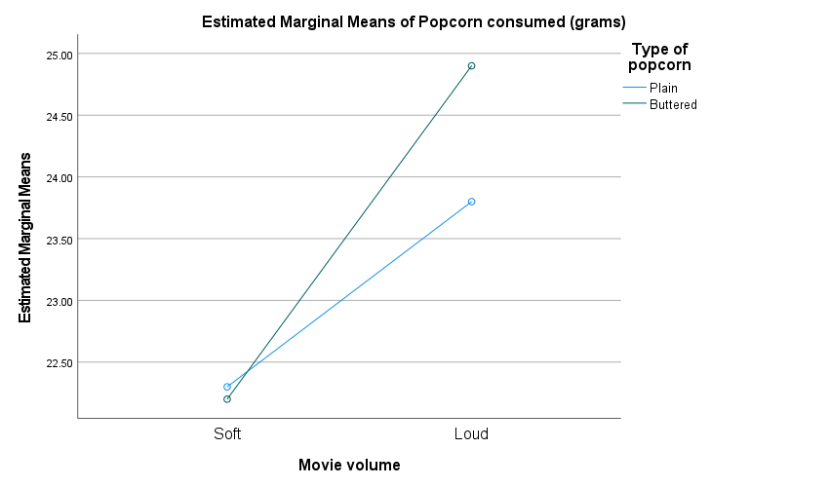

References
Field, A. (2018). Discovering statistics using IBM SPSS statistics (5th ed.). Sage Publications.
Privitera, G. J., & Wallace, B. (2014). Loud noise increases eating behavior in humans. Appetite, 83, 1–6.
He, J., Huang, Z., & Zhao, X. (2017). The effects of background music tempo and volume on food intake. Journal of Consumer Behaviour, 16(4), 331–340.

